How to deploy the existing SSIS package through integration catalog and reconfigure the existing job for package execution

Note: The server name, job names and paths are Examples here please follow the CR MOP for details

Step 1: Please download the package from the CR Tool and unzip the file and copy to server which we need to deploy.

Step 2: Double click on the SSIS Package file and click next on Introduction Tab. PFB screen shot

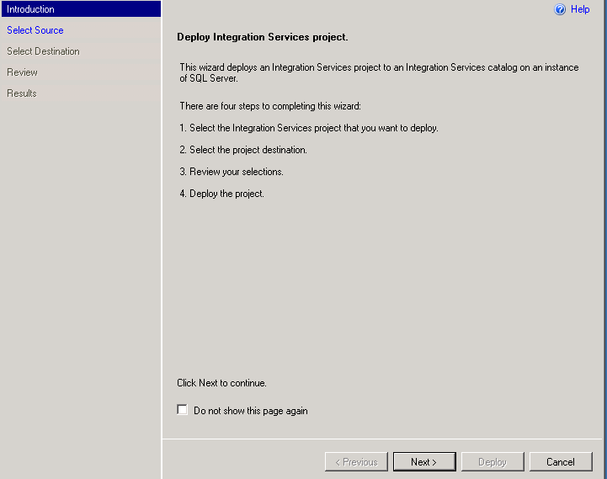

Step 3: Click next on Select Source Tab and it will ask for Password (please ask the team to provide the PWD). PFB screen shot

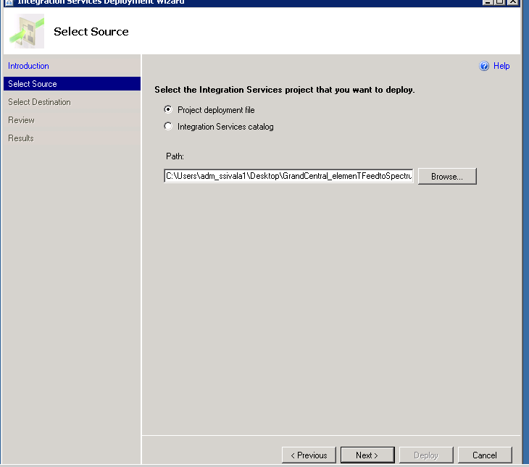

Step 4: Select the given Server name and given package here in the select destination Tab and click next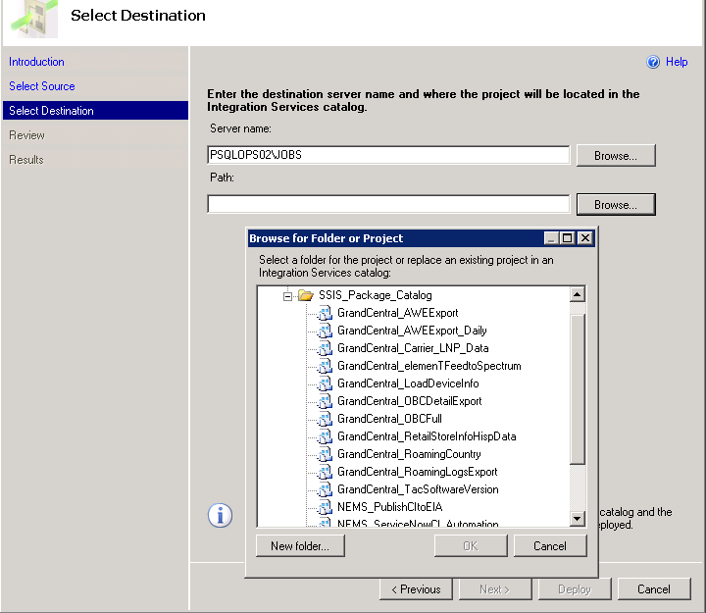

Step 5: Click on deploy to proceed the deployment.

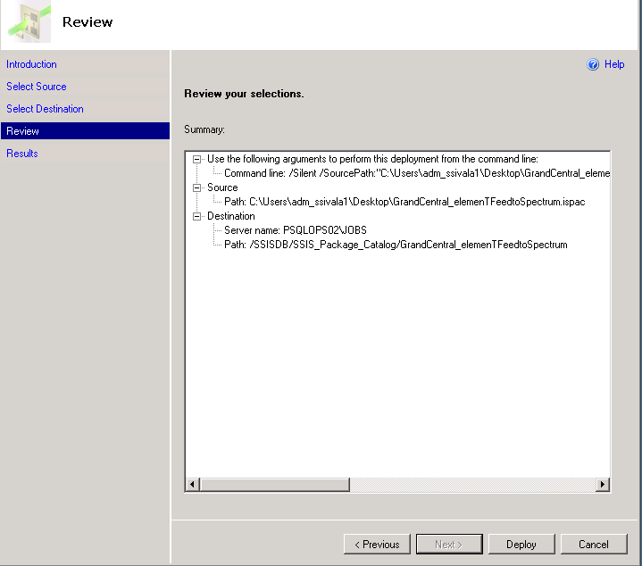

How to configure the existing job for package execution

Step 1: Go to the given job mentioned as per MOP

Step 2: Go to job properties 🡪 steps🡪 Edit

Step 3: Select package source as SSIS catalog and give server name as per MOP and Click on ok 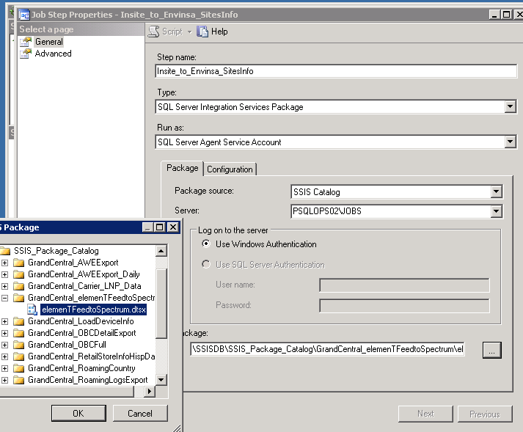

Step 4: Please run the job as per the team requirement. PFB sample screen shot

